**Verification Plan for MHMessenger Application**

**JNDI changes for Security Hardcoded Password**

* Check - application is up & running.

As we have made the required changes for jndi in applicationContext.xml and web.xml file in the MHM code. Now run the application at local space.

Login page will be visible for this app.

Now you can login and move forward with the verification of application.

Simultaneously capture the artifacts for proof.

* Artifacts:

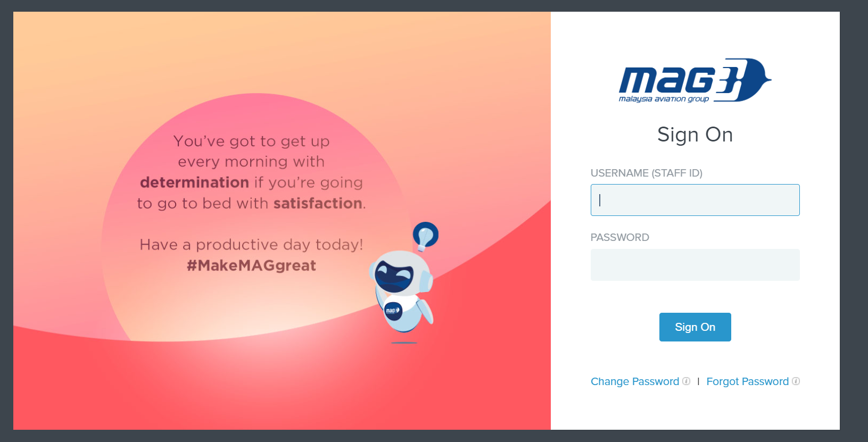

* Application Login is working fine.

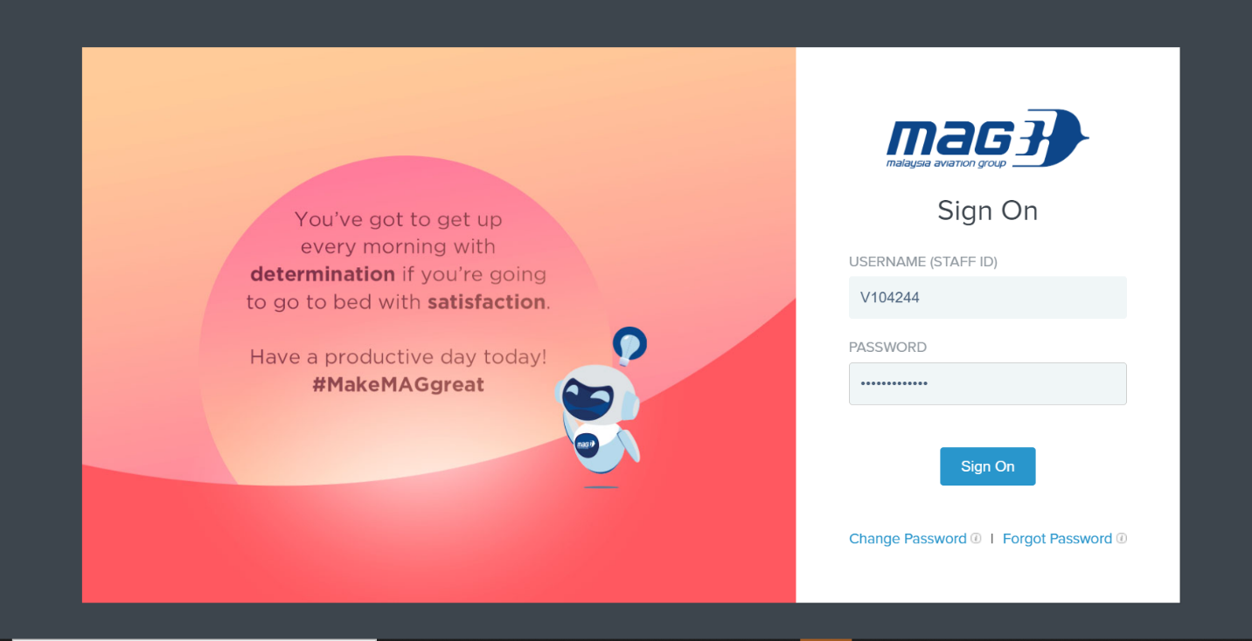

* Released functionality/Basic functionality.
* Home page - after login is successful

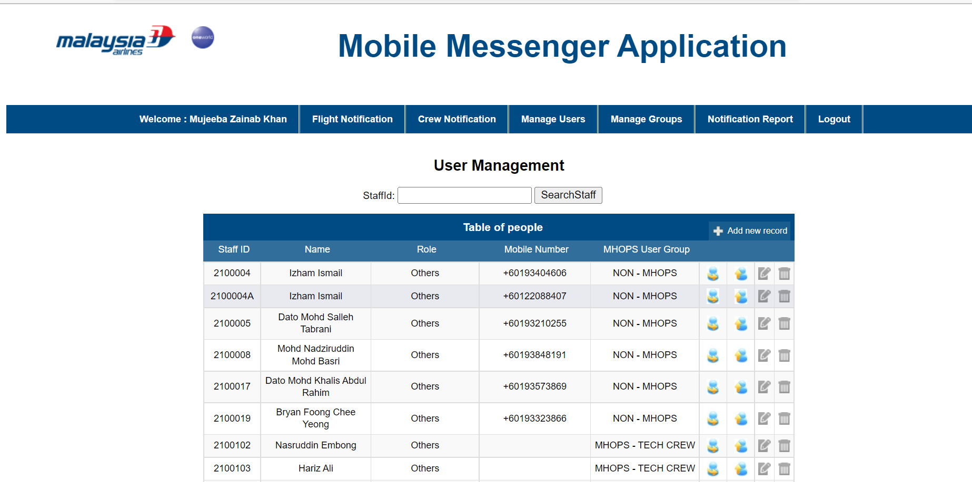

* Flight Notification Page

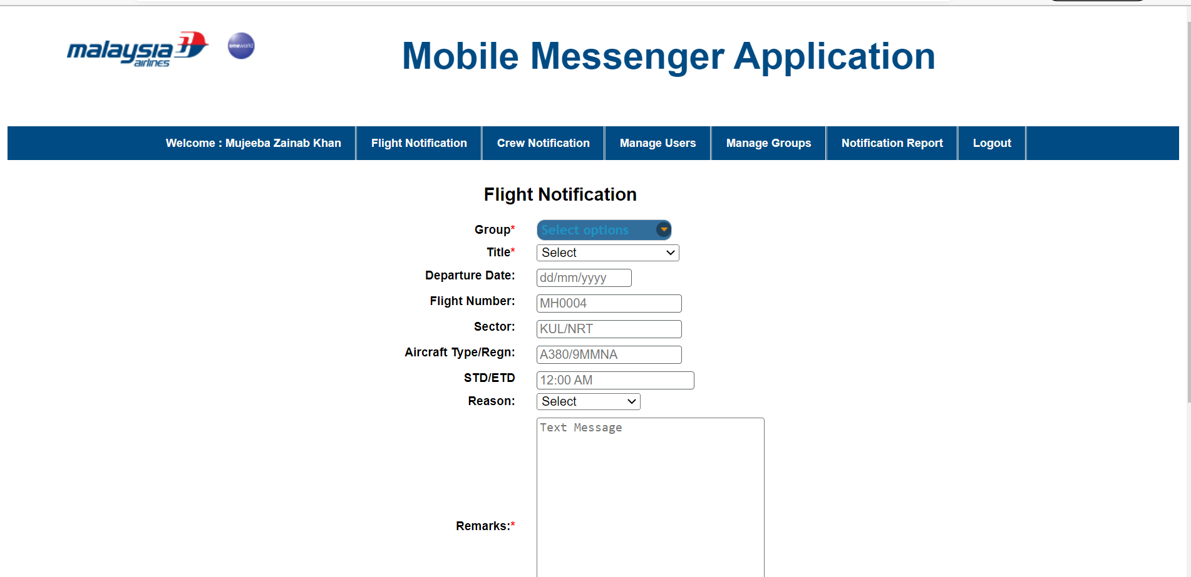

* Crew Notification page

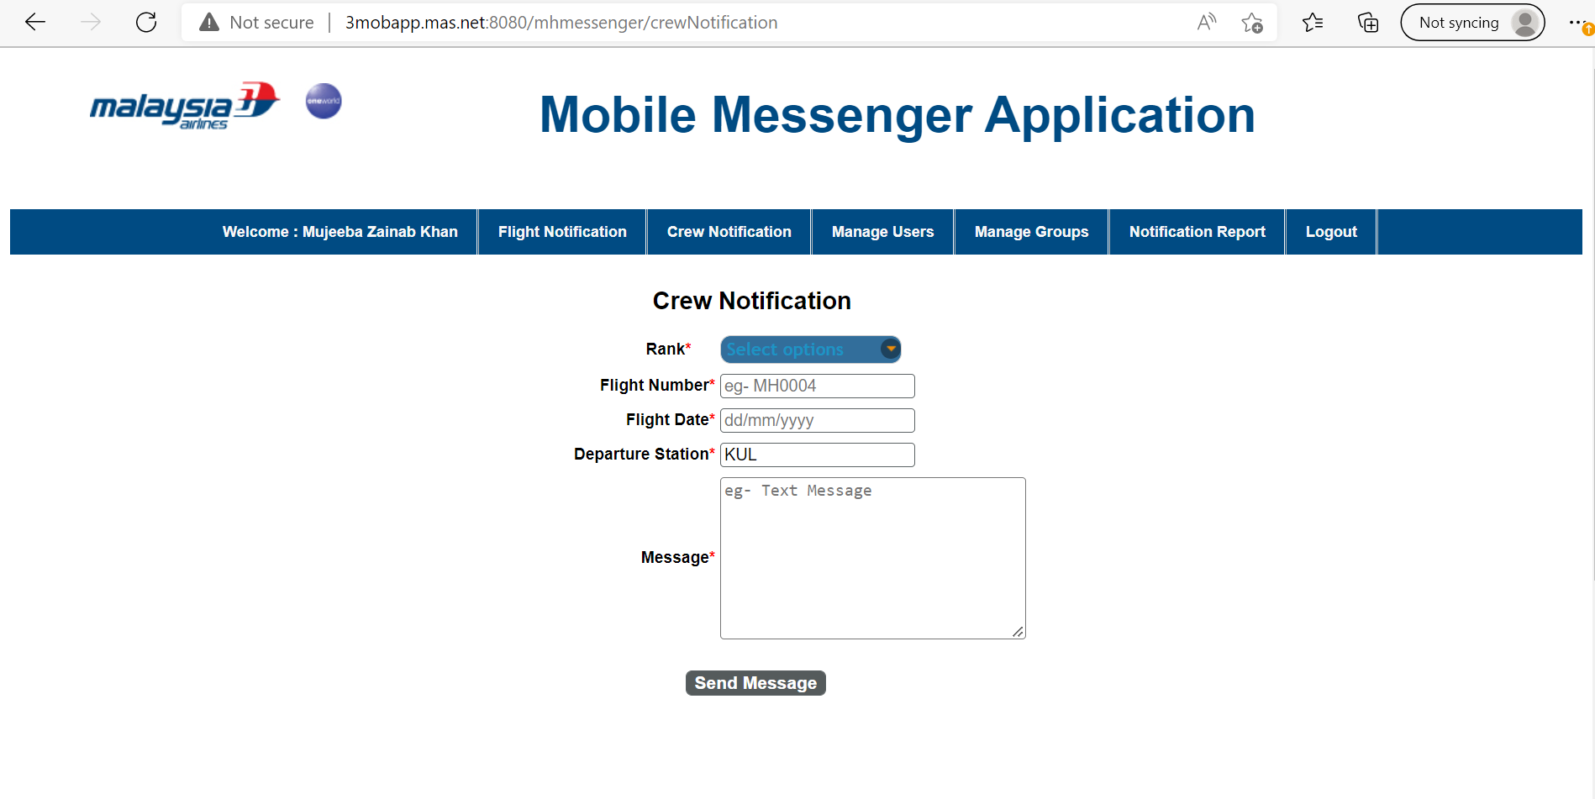

As we have validated the application and it is working fine, we can confirm the changes.